Bridgeport News
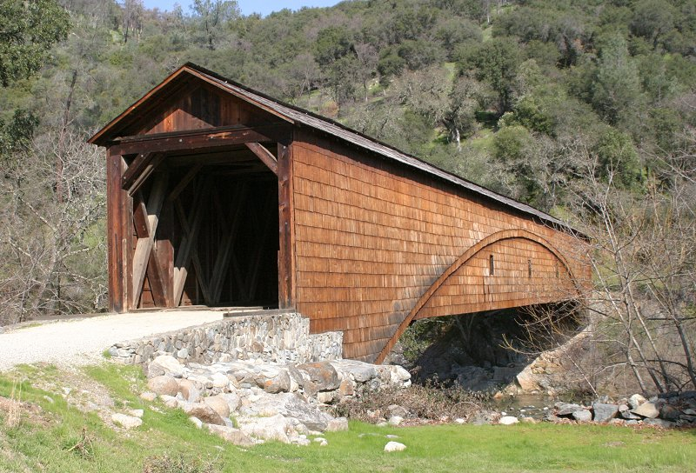
In This Issue
President’s Message | Pg 1
BRIDGEPORT RECEPTION | Pg 2
California Preservation  Foundation Conference | Pg 2
John Olmsted Lecture DVD | Pg 2
Gas Station Project Update | Pg 2
Independence Trail | Pg 3
New Buttermilk Bend  Trail Guide | Pg 3
Where is Anthony House? | Pg 3
Auto Tours of Bridgeport | Pg 4
Thanks to Contributors | Pg 5
Successful Fall Festival | Pg 5
Beautification Committee | Pg 6
Visitor Center Volunteers | Pg 6
SYRPA Website | Pg 6
Brief Calendar
Bridgeport Invitational Reception —Sunday, March 7, 2010, 2pm to 4pm in the Visitor Center. Docent training begins two weeks later.
Spring Festival – Sunday, April 25, 2010
10 am to 4 pm at Bridgeport.
Visit SYRPA website for latest schedule.
South Yuba River State Park
South Yuba River Park Association
President’s Message
Volume I, Number 3 December 2009

2009 was an exciting year for all involved in our State parks. The State’s budget shortfall was on the minds of State Park employees and volunteers. We were all relieved when we learned that all parks would remain open.
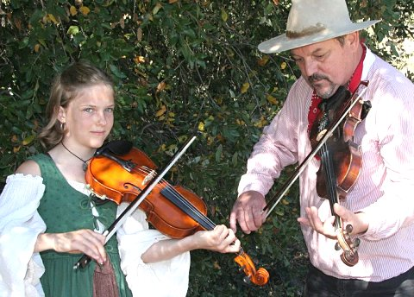
The South Yuba River Park Association decided early in the year that we would conduct business as usual. With the efforts of our volunteers and the support of the Park staff we had successful spring and fall festivals, gold panning at the county fair, flower walks, bird walks, gold panning, school groups, car tours, and various other programs.
During the spring the very popular self-guided tour was completed, landscaping around the visitor center was improved and, most recently, significant improvements were made to the native plant garden. The barn sign project was also completed. On a broader scope, the SYRPA board developed a strategic plan for the future protection and improvements of park assets. I want to extend a message of thanks to our many volunteers.
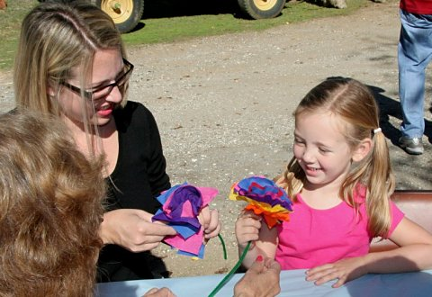
We are optimistic about the future plans and improvements for the park. We need to keep in mind that the success of the Park would not be possible without the many dedicated volunteers. Our need for new volunteers is always there and we ask that you pass this message to your friends and encourage them to consider exploring the possibility of joining us at our Park. Information about the March 2010 training dates is now available.
There are immediate association openings for treasurer, newsletter editor, webmaster, membership chairperson, planning committee chairperson, and planning committee staff. Please consider joining us in this worthwhile effort.
Ron Ernst
(Pictures here and on pp 5,6 from Fall Festival)…

The California Preservation Foundation Conference
May 12-15, 2010
Announcing the
BRIDGEPORT INVITATIONAL RECEPTION!
By Don Denton
On Sunday, March 7, 2010 from 2 pm to 4 pm, your association will host its Third Annual Reception at the Visitor Center.
At this orientation meeting each of our twelve volunteer coordinators will present their activities planned for our new year (e.g., Gold Panning, Wildflower Walks, Bridge and Barn Tours…).
As space is limited to the first 25 guests, all current volunteers and associate members are urged to contact the Visitor Center (432-2546) with their nominees’ names, addresses (postal and email), and telephone numbers, which will be placed on our invitation list for this year’s event.
These informal receptions go a
L-O-N-G way toward supplying us with the needed cadre of volunteers who help to make our visiting public’s experience at Bridgeport so enjoyable.
Light refreshments will be served, and there will be adequate time after these brief presentations for a question and answer period.
As this is your Association’s ONLY informal “Get Acquainted” program of the year prior to the Sector Training (for all three local State Parks—March 17-19 at Empire Mine) you are encouraged to invite your one BEST recruit to become a fellow Volunteer and Docent at Bridgeport.
As we envision 2010 to be “the year of the volunteer,” we’re asking for EACH ONE to REACH ONE!
Gas Station Project Update
by George Case
Editor’s note: As most of you know, our barn project has been completed and the small amount of grant funds that remained has been returned. Our next big project is to restore the gas station (“conserve”, the preferred method of maintaining historical objects, just won’t make it for the dilapidated building) to its condition in the 1920’s and 30’s during the height of the Kneebone Pleasure Resort and car travel across the covered bridge. George Case is project leader.
Great news – Ranger McReynolds has reported that progress is being made with the District regarding the station. I am working on a cost breakdown on what it will take to bring the gas station back to life. Docents are waiting in the wings to get started on paper work to include pads, grants, and most of all just working on the station.
New Buttermilk Bend Trail Guide
By Steve Pauly
The new Trees and Shrubs Self-Guided Trail brochure is almost complete. This new guide complements the Historic Ranch Self-Guided Trail brochure completed earlier in 2009. (Over 1,500 Ranch SGT brochures have been used by Park visitors since its introduction in April, 2009.) Identification posts for the 24 species mentioned will be installed by early next spring along the Buttermilk Bend Trail. The new SGT describes fourteen trees and ten shrubs, and includes leaf photos to help identify them.
South Yuba River State Park is part of a natural plant community called a Blue Oak Woodland. The key plant is the Blue Oak. Equally dominant species are the Interior Oak and the Gray Pine. The rainfall at the Park is higher than in the central valley, which promotes greater variety and density in its plants and animals. Judy McAuliffe selected and spotted the species for inclusion and prepared the text. Many of her descriptions include the uses made by the native Maidu along with interesting, sometimes whimsical, facts—all intended to be descriptive and easy to remember. Others contributing to the SGT are Ardie Obert (design & layout), Vicki Macdonald (content), Steve Pauly (concept & design) and several of the Wildflower Docents. Some of the docents already include tree and shrub identification in their wildflower walks, and one or more tree and shrub walks may be scheduled in 2010.
Auto Tours of Bridgeport
By Howard Voshell
Several tours have been given to auto clubs this year, most by George Case and Howard Voshell. The clubs are usually formed around a particular make of car, which included Mazda Miata, Porsch, 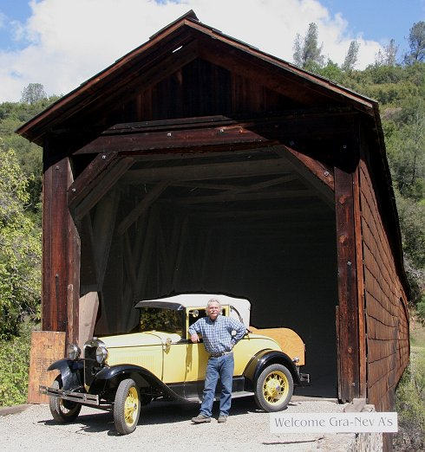Model A Ford, Corvettes, and P.T. Cruisers. One club was formed around vintage (1928 to 1932) luxury cars: Bentley, Rolls Royce, Lincoln, and Duesenberg. Club members were uniformly enthusiastic about the tours and thanked us profusely, some with donations up to $100 in addition to the standard $5 per car fee. Herb Lindberg was there to photograph the Model A’s and P.T. Cruisers. For each club he created a CD of all his pictures and mailed them to the club presidents for distribution to the members. He also posted selected photos on his website, with the clubs’ permission. (See the links near the bottom of page http://syrpa.lindberglce.com/autotour.htm.) We received email thanks for these efforts as well.
Thanks to
Financial Contributors
By Ardie Obert
With State Park service cuts in funds for SYRSP, our association plans to step up and fill some of the gaps. We will know soon how much we will be asked to contribute to Visitor Center expenses and other items to be identified. This means SYRPA dues and contributions are more important than ever. We thank the following individuals and organizations for their recent contributions: Ron & Susan Ernst, the Captain Oldham Chapter of the DAR, Colin & Katherine Phillips, Mary Boudinot, and 16-year volunteer service veteran Judy Nichols. Judy teaches Pine Needle Basket classes and for the past twelve years has donated the proceeds to SYRPA.
A Successful Fall Festival
by Herb Lindberg
Thank you to Roberta Canier and the many volunteers who made this an outstanding event. I’ve heard visitors say this was the friendliest, most active festival they’ve attended at Bridgeport or 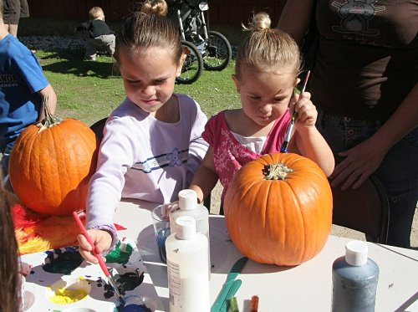any local park. No matter where I looked visitors had smiles on their faces and they were busy having fun as they learned about the history, flora and fauna of the park. I noticed in particular the wildflower and Halloween craft tables run by Vickie Macdonald and Jean Wilson near the old gas station, a great idea 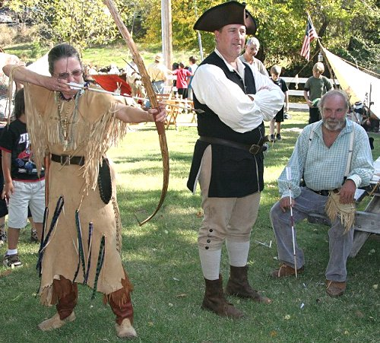and new addition this year. Children loved making colorful paper flowers, and paper bats with clothespin holders. 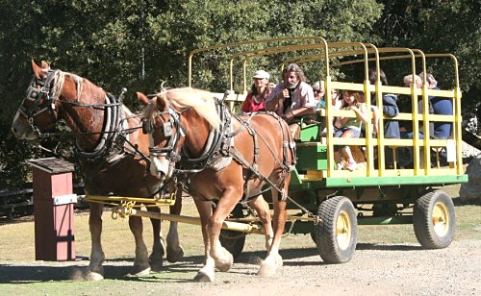Bridgeport Bingo was also a big hit, as was bean bag toss into a donkey, ring toss, and on and on. Go to http://syrpa.lindberglce.com/Recent/2009_Fallfest/09Fallfest1.htm for a more complete photo story.
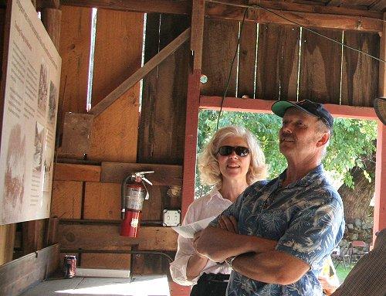
All the pictures here and on Page 1 are at the above link in larger size.
Stay active
Enjoy Life
Spread knowledge and joy
Sustain SYRPA and SYRSP
Volume I, Number 3 Page 2
By Diane Marten
As early as last Spring, Don Denton and I started to attend meetings to prepare for the upcoming California Preservation Conference to be held in Nevada County in May of next year. It has been an exciting adventure as we watched our friends from many organizations throughout Nevada County vie for participation in this wonderful event. The Conference will bring together experts in various fields of preservation throughout California who will demonstrate the Foundation's commitment to the protection of California's diverse cultural heritage and historic places.
This will be the 35th annual Conference and, to our great delight, Bridgeport has been chosen as a destination for an exclusive tour and place for study. The South Yuba River Park Association has asked our own Donna Jones and Bill Lindemann, who together were instrumental in spearheading our Barn Restoration and Wagon Procurement and Interpretation Project, to host this special presentation.
Many of us will be needed to help prepare and assist in this conference, both at Bridgeport and at the Convention headquarters at The Miner's Foundry, and at various locations in Grass Valley. Please look for the "Save the Date" postcard which everyone will be receiving soon.
As an added enticement, our wonderful "Fall at Bridgeport" photo by Betty Kelly was chosen not only for the postcard, but also for the cover of much of the Conference's mailings going out all over California. Don and I are so proud to have had Betty's beautiful photo chosen for this special honor. So mark your calendars and let us know if you would like to participate in this exciting event.
John Olmsted Lectures on Park History and Vision
by Herb Lindberg
John Olmsted is giving a series of three lectures, at one month intervals in the Visitor Center, to park volunteers on the origins of South Yuba River State Park. (Seating is limited, so if you would like to attend please call Ranger Jennifer or Ranger Mike.) John’s emphasis is on how land for the park was identified, purchased, and turned over to the California State Parks, but his story is much more wide ranging. In Lecture 1 (October 14, 2009) he began with John Muir (born exactly 100 years before John Olmsted), his treks, and the origins of Yosemite and Yellowstone Parks and the national park system. John hinted at how he was able to fund purchase of land for Bridgeport and for the Independence Trail. I presume we will hear this in more detail in Lectures 2 and 3. The lectures are being video recorded and will be available on DVDs at the VC. The first DVD is completed and runs 1 hour 31 minutes. A copy is available in the Visitor Center.
Volume I, Number 3 Page 3
News From Independence Trail
By Linda Chaplin
The Independence Trail stretches along the south wall of the South Yuba River Canyon, following the course of the historic Excelsior Ditch, completed in 1859. The nearly level grade of the ditch makes an easy trail for visitors of many different levels of ability to use to access the shady canyon forests of this part of the South Yuba River State Park.
The trail gets a wide range of users: wheelchair visitors, grandparents pushing grandkids in strollers, families with children, couples walking their dogs, young people hiking with their friends; all come out to share a special connection with nature.
People arrive from many different places to enjoy a day on the trail. Many visitors are locals, coming here often to walk, hike or run. Other visitors are from nearby regions; Marysville, Reno, Sacramento; still others are from farther away in the State, or even out-of-state. We even see international destinations written into the trail log: visitors from Canada, Europe, Asia, South America, Australia, and New Zealand. The Independence Trail inspires people from around the world.
Besides the beauty of the forest, the historic features of the ditch add interest to any hike: the mossy rock walls covered with ferns in springtime, and the wooden bridges, called flumes, arching over creeks and across canyons. These all hint of another past, another use for the ditch, before it was a hiking trail; back to the times when water flowed through it to power the hydraulic monitors washing the gold gravels of the Smartsville Diggins.
With this year’s tight Park’s budget, there are few resources to maintain the Independence Trail. If you would like to help with its upkeep, you can make a donation to the Independence Trail Fund at the California State Parks Foundation. Fund money will go toward maintenance and restoration projects on the Independence Trail. Thank you for your support. Please make your checks out to: CSPF (indicate for the Independence Trail Fund); you may include “Attention: Michael Bankert, VP” on your check and envelope.
Send to:
CSPF (California State Parks Foundation)
50 Francisco Street, Suite 110
San Francisco, CA 94133

Where is Anthony House? —A Sequel
By Dick Alexander
Following publication earlier this year in Bridgeport News of "Where Is Anthony House?" ( no requests to date for a scuba-diving field trip!), further research and oral history have provided sufficient information to warrant designation of the site by the Nevada County Historic Landmark Commission as an historic landmark. The designation specifies erection of a commemorative plaque at Lake Wildwood Dam, a process already underway. More on this in a later newsletter.
Meanwhile, one historical resource, the book The Northern Mines (1949) by Edmond Kinyon, historian and reporter/editor of The Union for 35 years, relates this fascinating account of Pleasant Valley in his chapter entitled "A Valley of Strange Doings":
Volume I, Number 3 Page 4
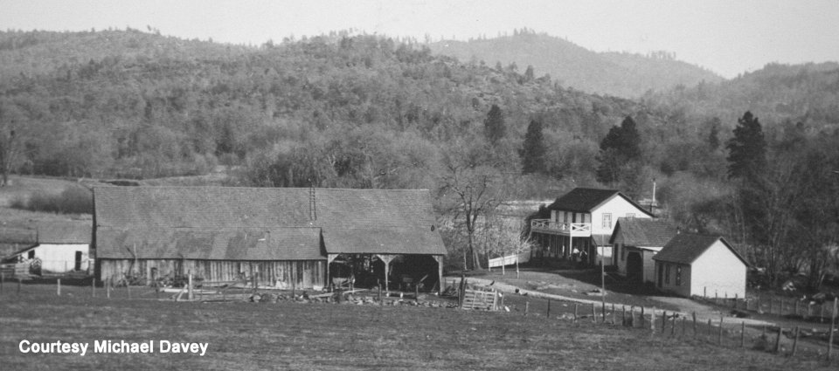
The original Anthony House, a famous stopping place on The Road in Pleasant Valley, burned in 1876, but it was rebuilt and still stands, a drab, shrunken structure around which cluster many curious tales. Search for the identity of its original builder and its early history has been unproductive. Newspaper accounts of the fire of August 4, 1876, mentioned S. P. French of Colusa, California, as the owner and stated that "it was settled by him in 1849."* Incidentally, William Westerfield, who was operating the road house and its inclusive store and bar, lost "between $12,000 and $15,000 in currency and U. S. bonds" in the fire. Faith in banks, it appears, was not a strong point with Westerfield. So he kept his wealth hidden on the premises. Although the fire occurred in mid-afternoon, the proprietor was asleep and unable to do more than to save himself from the flames.
Anthony House as seen from what is now the roped swim area near the pavilion in Commodore Park, Lake Wildwood (it was destroyed in a fire exercise before LWW was flooded)
Many different individuals appear to have had a turn at conducting Anthony House during the early and middle periods, but whether through ownership or lease is uncertain. One transfer is presumed to have involved a particularly vicious practice all too frequent throughout the mining country during the first decades—that of liquidating a debt or paying for a property, and a few hours later stealing the money back by stealth or disguised banditry, sometimes involving the murder of the rightful owner.
Before giving a summary of Hoffman's version of such episode it is well to mention Friederiche, an enterprising highwayman who specialized in sticking-up Chinese miners slip-footing The Road to their cabins. Following one such robbery, the depleted victims hurried to their settlement, armed themselves with a shotgun and sent two of their countrymen to the same scene as decoys. Sure enough, Friederiche, nothing loath, stepped out for a second haul. It was then that a shotgun blast roared from the rimming brush, whereby the bold robber lost his head—and not in the figurative sense either.
Volume I, Number 3 Page 5
Previously, two men who owned property at Anthony House agreed to dissolve partnership, and one paid the other $6,000 for his share. The next morning the buyer reported that his late partner had fallen into Deer Creek and drowned. He seemed more perturbed over the absence of the six thousand dollars which he had so recently paid him than over the death of his former associate. The surmise was that the canny seller had lost no time in burying the money. But that may not have saved him from being pushed into flooded Deer Creek.
Two or three years later it was found necessary to dig a grave for the unlamented Friederiche. After the custom of the times, men took turns at the digging job. The one momentarily on shift believed that his pick struck some iron substance. Thoughts of buried money flashed through his mind. Thereupon he peremptorily halted the excavating, declaring that the grave was plenty deep for a highwayman. Others of the crew offered to dig it a little deeper, but the self-appointed boss would not listen. Without more ado he pitched cadaver Friederiche into the shallow opening and shoveled the loose earth upon him. That done, he invited his co-workers to the Anthony House bar for refreshments.
But the man who sensed the presence of the drowned man's six thousand dollars was in no hurry. He felt that his find could wait. Or he may have experienced a trifle of squeamishness. In any event, it was not until thirteen years later that he enlisted the aid of two friends to open the Friederiche grave and lift the cache. It was a night job, but they found the location and dug down. The money was not there, neither were the bones of Friederiche. Another mystery of Pleasant Valley that never was solved.
Who opened the grave and removed the body of the highwayman? And who lifted that presumed money cache? Or did one man or group of men do both jobs?
To conclude that particular narrative, Adrian H. Hoffman drops into the fantastic with this question: "Could it be that Friederiche himself, true to his acquisitive propensities, got up out of his grave, took the money-kettle under his arm and departed?"
The moral of the episode seems to be that if you strongly suspect a treasure cache, do not wait thirteen years before putting your hunch to the test.
*Recent research by interested persons indicate that the Anthony House location was originally staked by a man named Anthony and that the name clung long after the identity of first builder had been forgotten. According to that version, S. P. French was a slightly later owner.
**Newsletter note: While not part of the Park (SYRSP), Anthony House was an important stop on the way from Marysville to Bridgeport and is therefore an important part of the history we interpret for our visitors.
What's Been Happening
with the Beautification Committee?
Volume I, Number 3 Page 6
By Mickey Springer
October 20th was the perfect day—sunny, trees in shades of yellow, and leaves falling—a lovely fall day. The rain from a week earlier left everything fresh and clean, perfect conditions to spruce up the Park and get it ready for the Fall Festival. At least fifteen volunteers responded to a work party request to come to Bridgeport and clean up areas around the Visitor Center. The pile of river rock is now gone; some of it was added to the border of the NPG (Native Plant Garden) and the rest has been moved out of sight. A BIG thank you goes to Frank Hamlin for bringing his tractor to move the rock.
More Star Thistle was cleared, the rose bushes on the VC porch pruned, old and dead blackberry bushes cleared away, the remaining decomposed granite spread, and numerous other clean-up jobs accomplished. Thank you Kay, Pat, Nancy, Frank, Ellen, Ron, Darlene, Vicki, Sharon, Dave, Clint, Ardie, and Steve—if I've overlooked anyone, my sincere apologies. Thank you also goes to Frank, the Park's maintenance helper, who took away the piles of debris. The final touch to the Native Plant Garden was placement of a sign designating the NPG, and guess who made the sign—our very own Jeremy McReynolds! OK, Jeremy, now we know your other talents, you may get asked again in the future for another sign. Thank you for a great job.
By the way, the Native Plant Garden is looking very good. If you haven't taken a walk thru it, do so. Nancy has added a few more native plants and given some tender loving care to the others. Can't wait to see the results next Spring.
Come Spring, I know we'll have another clean up scheduled for the Park. I'll be calling upon you all!

Wanted: Visitor Center Volunteers
By Patricia Stein
Volunteers, especially men, are needed urgently to supplement the dedicated group serving the public by keeping the Visitor Center open and attractive. Two persons should be on duty during the open hours. This is essential now that the reduced crew of rangers is spending less time at the Park, and the volunteers are alone in the VC more now than in the past. If you can help with this vital part of our support to the Park, please contact Daphne Towns (432-3659) or Sharon Anderson (432-2359).
SYRPA Website
Don’t forget to visit, and tell visitors about, our website:
http://www.southyubariverstatepark.org/index.html
This is the best place to get quickly accessible information about the many park activities, and the latest schedules for upcoming events.

