Bridgeport News
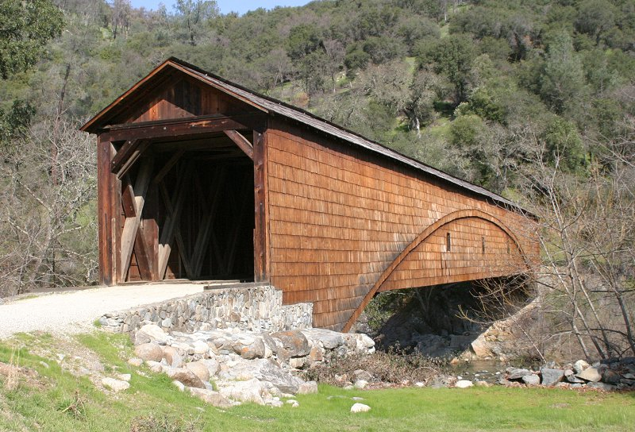
.
In This Issue
President’s Message | Pg 1
Bridgeport News – Thank  You Dennis Monax | Pg 2
More About Our Website | Pg 2
Self-Guided Trail | Pg 2
Visitor Center Planter Box | Pg 2
Wildflower Update | Pg 3
Spring Festival at the Park | Pg 4
Eagle’s Nest Discovery | Pg 4

Docent Hours in March
Activity | Visitors | Hours
Interpretation/  school groups | 189 | 214.5
Visitor Center | 946 | 235.5
Public Relations |  | 3.0
Maintenance |  | 27.0
Resource  Management |  | 7.5
Totals | 1135 | 487.5
Thanks for all the hard work!!
Ranger Jeremy Alling
South Yuba River State Park
South Yuba River Park Association
President’s Message
Volume I, Number 1 May 2009

Since the last newsletter we have had a lot of activity at Bridgeport. In March we had training for a large group of enthusiastic new docents. Wildflower tours have been conducted by very knowledgeable docents, and have been well attended due to the favorable weather.
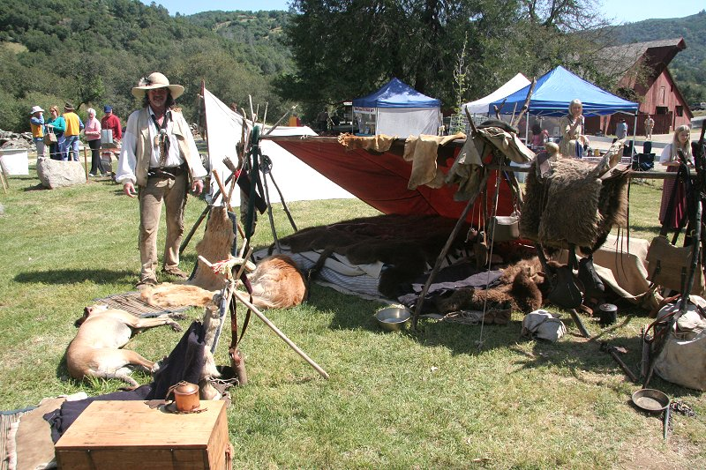
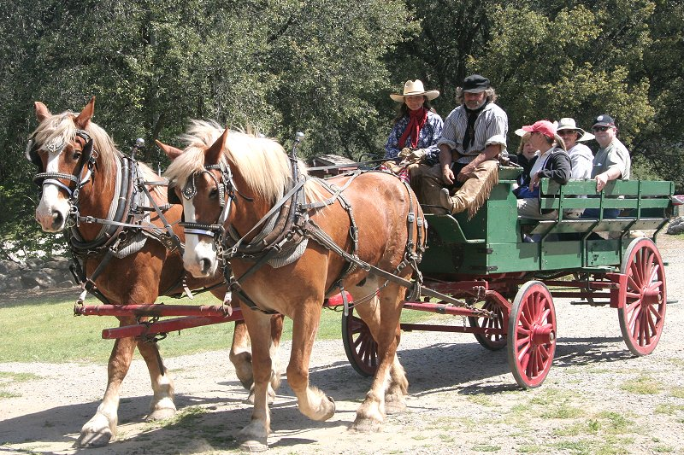
Attendees of Bill Cortright’s bird walks had a special treat by the discovery of a nesting pair of bald eagles. The nest is located in a very visible location, allowing many visitors to observe the nesting and feeding activity. At this time, beginning of May, the young birds are close to taking their first flight.
Under the leadership of Steve Pauly a self-guided tour has been completed with brochures and location markers. The tour covers the interesting points from the bridge to the cemetery.
Mickey Springer, with help from hard workers, has completed the first stage of the visitor center beautification project consisting of two flower boxes near the center entrance.
The planning committee has been hard at work developing near and long-term goals for the Park. Details will be provided in another report.
On Sunday, April 26, we had the Spring Art Show & Sale combined with Living History Day. The event was held in perfect weather and with a steady flow of visitors throughout the day. The event was organized by Roberta Canier with great assistance from the many docents and rangers.
Highlights of the day were live music, gold panning, blacksmithing, wagon rides, bridge and barn tours, mountain men/women encampment, art sale, raffle, food and ice cream, and more. It was obvious that visitors of all ages had a good time.
George Case, with the help of a number of volunteers is hard at work preparing our float for the Penn Valley Rodeo parade to be held on Saturday May 16, at 1:15 PM. It’s a fun parade. Don’t miss it.
Ron Ernst

Bridgeport News – Thank you Dennis Monax

Self-Guided Trail
Ready for Use
by Steve Pauly, Docent
The Bridgeport Historic Ranch Self-Guided Trail (SGT) was completed in time for the April 26 Spring Festival. The SGT includes 16 Points-of-Interest in and around the Bridge, Barn, Visitor Center, Gas Station, and Kneebone Cemetery. A brochure and map are available at all times, outside next to the Visitor Center front door.
Dick Alexander and Paul Fluckiger selected the points-of-Interest, Mickey Springer and Ardie Obert designed the trail brochure, Dick Alexander contributed the text, Herb Lindberg adapted the Park map for the SGT, and Steve Pauly coordinated the effort. Rangers Jeremy Alling and Marc Wetherbee helped install the numbered 4 x 4 posts. Thanks to all who contributed to this effort.
As new information becomes available, the brochure will be revised or expanded and new points-of-interest will be added.

Visitor Center Planter Box
by Mickey Springer, Docent
The seed was planted last summer by Steve Pauly, and today the concept has blossomed (yes, this is an intended pun), and we have two beautiful planter boxes along the ramp to the Visitor’s Center.
A Beautification committee has been formed to enhance the beauty of nature and historic structures at the Park. The planter boxes were our first project. The design and selection of plants were the easy part, but figuring out how to build it, how to bring in the soil, gravel, rocks, and how is it going to be watered? Those were the problems to solve.
Well, I should know better – all one has to do is put out the word and our wonderful docents start coming forward with their assistance. Someone told me to contact Bill Haselhorst, and I did, and he came out and took measurements, bought the lumber and had them built – and they are good looking and sturdy. Ron Ernst heard what was happening and said he and Steve Pauly could bring in a drip system, and long before I knew it, the PVC was in and ready to add the emitters.
One day while attending other business at the VC and talking with George Case about where I was getting the soil and rocks, George volunteers his dump truck and the next day he delivers the soil, gravel and river rock! I can’t stop here when acknowledging everyone’s willingness to help – Brody, our grounds maintenance man, when seeing there was a pile of soil left over and needed to be moved to a spot out of sight in preparation for the Spring Festival, said he would handle that for me.
I thank you all for stepping forward and assisting in this project. We now have plants in those boxes that should give color thru spring, summer and fall – we don’t have to worry about them being watered, and the boxes have added an attractive entry to our VC. Most of all, I am privileged to have an enthusiastic committee with ideas and goals for other areas in the Park. Those individuals are: Nancy Chittenden, Sharon Anderson, Marilyn Chabino, Kay Lundgren and Judy McAuliffe. Thank you all for your efforts and volunteerism.

Eagle’s Nest Discovery
by Bill Cortright
photo by Walt Carnahan
On my February 28 Bridgeport bird walk, we saw a stick-gathered raptor type nest near the top of a pine tree. We wondered about a splash of white that was noticeable above or in the nest. Our binoculars could not identify this as a bald eagle but presented a likely chance that it might be. We were not carrying a spotting scope with us at the time, but I made a point of checking the nest with a scope before my March 14 bird walk.
The Tuesday before the second bird walk, I used my spotting scope on the nest during my preliminary survey before the walk. When I set up my scope on the nest, I saw a bald eagle feeding what looked like a fish to another bird in the nest. Then on March 14, we saw a bald eagle on the nest and another one in a tree nearby. The eagle on the nest was making movements that suggested eggs had been laid.
I saw a bald eagle on the nest again on March 23 and April 2 two days before my third bird walk. On this third bird walk, we saw the two eagles again and in the nest we also saw at least two eaglets. Additional sightings are recorded in “Tell us the Birds You Saw Today” on the Visitor Center table. Walt Carnahan has a photo that seems to show three eaglets. Twice since I’ve seen an eagle in flight and then saw one on the nest and one on another tree. In late June or in July we can expect to see pre-flight and eventual fledging by the new-born eagles.
Newsletter Contributions
If you have something interesting to share, please send your article via email to our President, Ron Ernst, who will see that it gets to our new Bridgeport News editor.
Volume I, Number 1 Page 2
After more than six years of editing, formatting, printing, and emailing the Bridgeport News, Dennis Monax has taken a well-deserved retirement from this responsibility. We cannot thank him enough for his reliable dedication.
A permanent replacement has not yet been found, but in the meantime the Board has decided to format the newsletter for ease of reading directly on and printing from the new SYRSP website. It therefore appears in sequential letter size pages. Everyone is encouraged to read it on line. Back issues will be archived on line with easy access by anyone interested. Please use the website and tell your friends: http://www.southyubariverstatepark.org.
Each month, Association members and friends will receive email reminders that the Newsletter has been posted on the site. Members without access to a computer will be encouraged to pick up their Newsletter copy at the visitor center. Hard copies will be mailed when necessary; however the Association is trying to avoid unnecessary postage and retain maximum funds for the benefit of the Park.
More About Our New Website
In case you haven’t heard, after months of discussions among Dennis Monax, Herb Lindberg, Steve Pauly and Jennifer McCallan, Jennifer has created a beautiful site which she published fully formed this March. It is not often that a new site appears with most of its features up and running for use by visitors. Rather than describing its beautiful and useful features, you are encouraged to use the link above and see for yourself.
The new website is becoming the center of Association communications, and posting the newsletter to the site is just the first of many transitions to that goal. In the coming months:
- A Newsletter archive will be available.
- A ‘Docent Only’ section will provide access to docent duty sign-ups (e.g., Becky’s calls for volunteers), board minutes, the budget, committee reports and the member roster.
- Trail maps will be on-line to view and print.
- Self-Guided Trail brochures will be on-line to view and print.
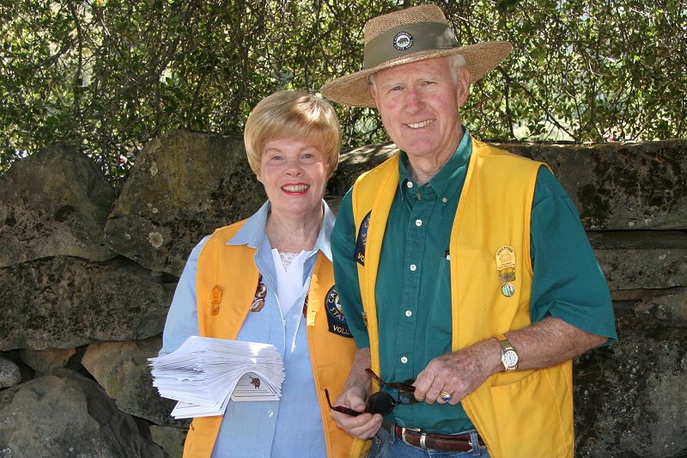

Linda and
Don Denton
at the History
Station during
Spring Festival

Wildflower Update
Volume I, Number 1 Page 3
by Vicki Macdonald, Docent
We are having another successful year sharing our beautiful wildflowers with park visitors on the Buttermilk Bend Trail. We have 17 docents leading the public walks on the weekends and a few more specializing in private tours and school groups. We are excited that several docents from the recent class have expressed interest in learning more about the flowers and possibly doing tours in the future! By the end of April we had almost 300 people join us for the weekend walks. This should be a record breaking year, since last year’s total was around 320. The grasses are growing tall and beginning to crowd out some of the flowers but the late bloomers should be flowering soon. Look for Elegant Brodiaea, Elegant Clarkia, Narrow-leaved Daisy, Gumplant, Woolly Sunflower and Penstemon among others.
We had a great tour of the vernal pools at Jepson Prairie Preserve and learned the fascinating story of the solitary bees (so called because the female lives alone). These bees choose one of 5 species of vernal pool flowers and pollinate that one exclusively. The female digs a vertical hole with lateral branches. She deposits pollen into the branch until she gets a large ball that she moistens with nectar. Then she lays her egg on top (one egg per branch), covers up the brood cell and has no further contact with her offspring! The newly hatched larva feeds on the pollen ball then remains dormant until September when it transforms to a pupa. It overwinters in the ground until spring when it hatches at the same time as its special flower to begin the cycle all over again! The male bees mate with the females soon after hatching then take off, their work being done.
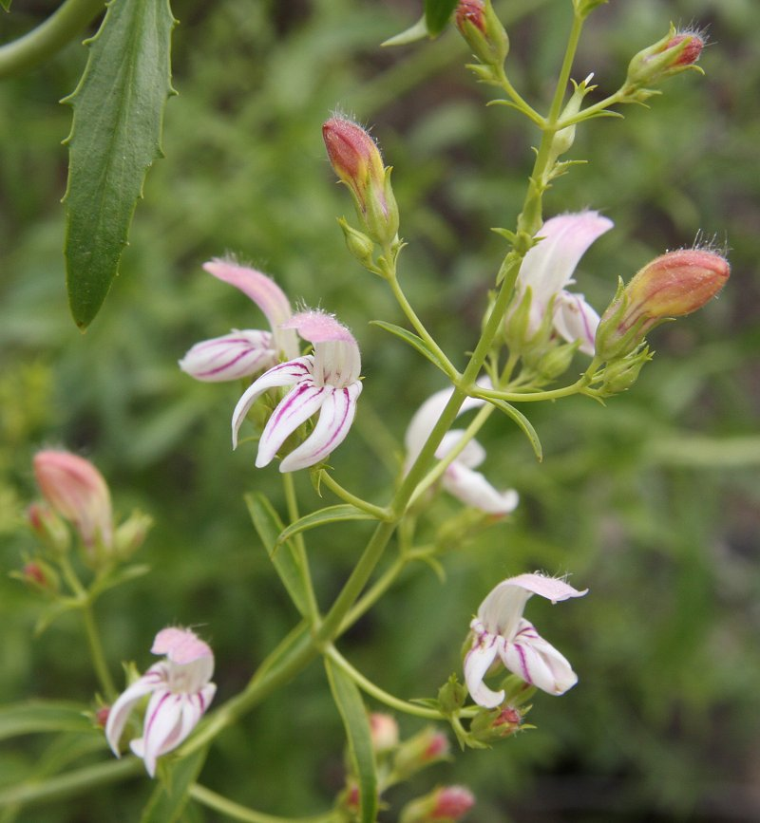
Gaping Penstemon on Buttermilk Bend Trail, April 30, 2009
Photo submitted by Barbara Heninger

Spring Festival at the Park
by Roberta Canier
Volume I, Number 1 Page 4
More than 375 people enjoyed the LIVING HISTORY DAY and ART SHOW hosted by the South Yuba River State Park on Sunday, April 26, 2009. Nature cooperated with us and provided an absolutely pristine Spring Day for this annual event.
While many people attended the events, sampled the food and toured the art show, we noticed that a large number of people were taking advantage of the trails and otherwise enjoying this special place.
Thanks to all the docents who made this event possible, including gold panners, our historic characters, barn tour guides, roamers, greeters, blacksmithies , gift shop clerks, and raffle hosts. Outside vendors that contributed to the Festival included the Sierra Muzzle Loaders, the Penn Valley Chamber of Commerce, Ann Tatum and her wagon, and The Big Dipper Ice Cream Company. The mountain man overnight encampment added a mid-1880s scene to the lawn in front of the Visitor Center. Black powder explosions punctuated the muzzle loader and 3-lb. cannon demonstrations. And last but not least, let's applaud the artists who exhibited regional artwork.
Special notice must be given to the Rangers who provided assistance wherever needed: Ranger Mike, Ranger Jeremy, Ranger Jennifer, Ranger Wayne, Ranger Mark and Ranger Jeremy #2. The Rangers are our unsung heroes!!!! Ranger Allie did not participate but we know that when needed she is there.
Thanks to all who contributed to this rousing event and helped further introduce South Yuba State Park to the public.

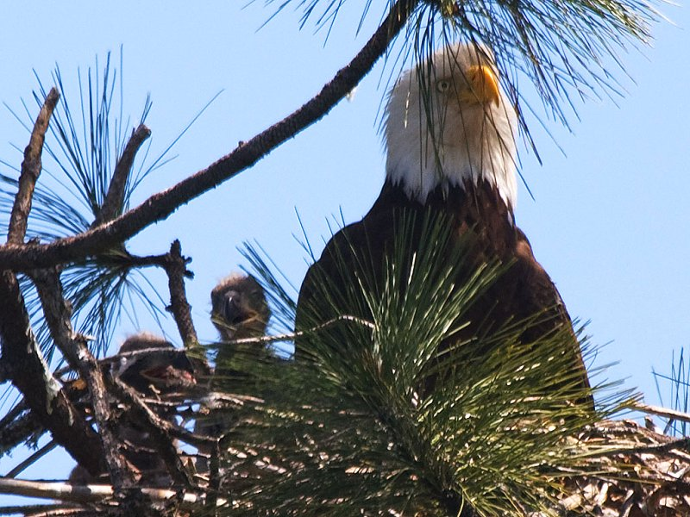
Don’t forget, visit http://www.southyubariverstatepark.org

